Instructions for setting up the database

- Signup for an account on http://www.supabase.com

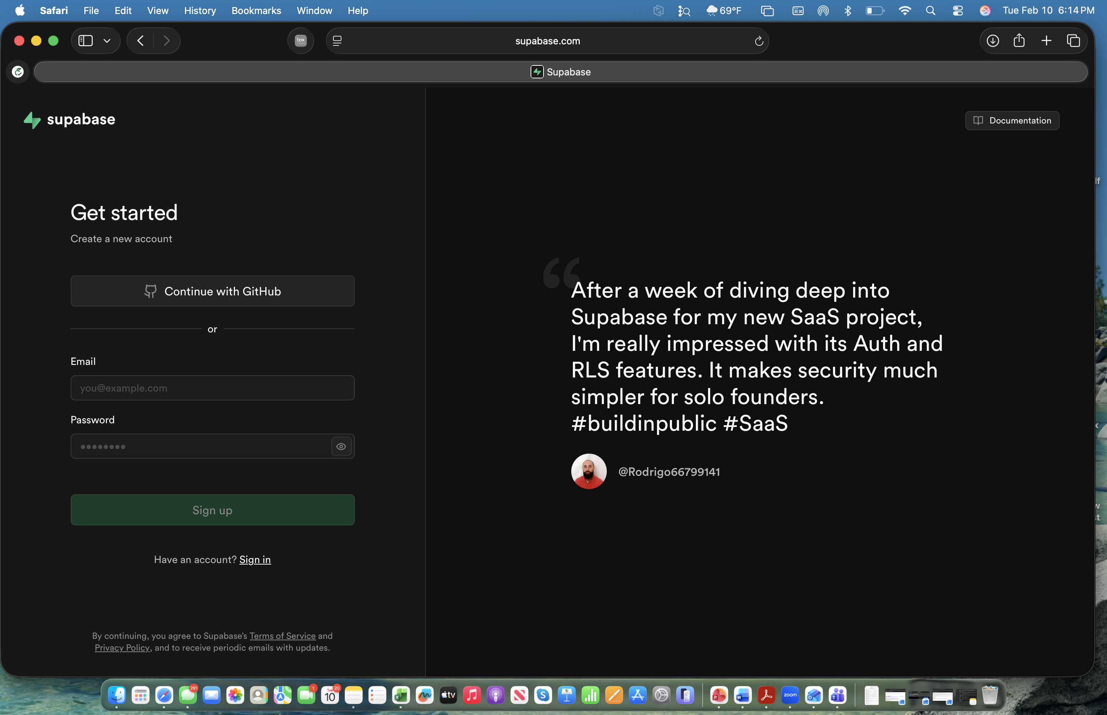

2. Confirm your account through your email and login again
3. Enter the organization name, use the free plan option as shown below, and click on “create organization”

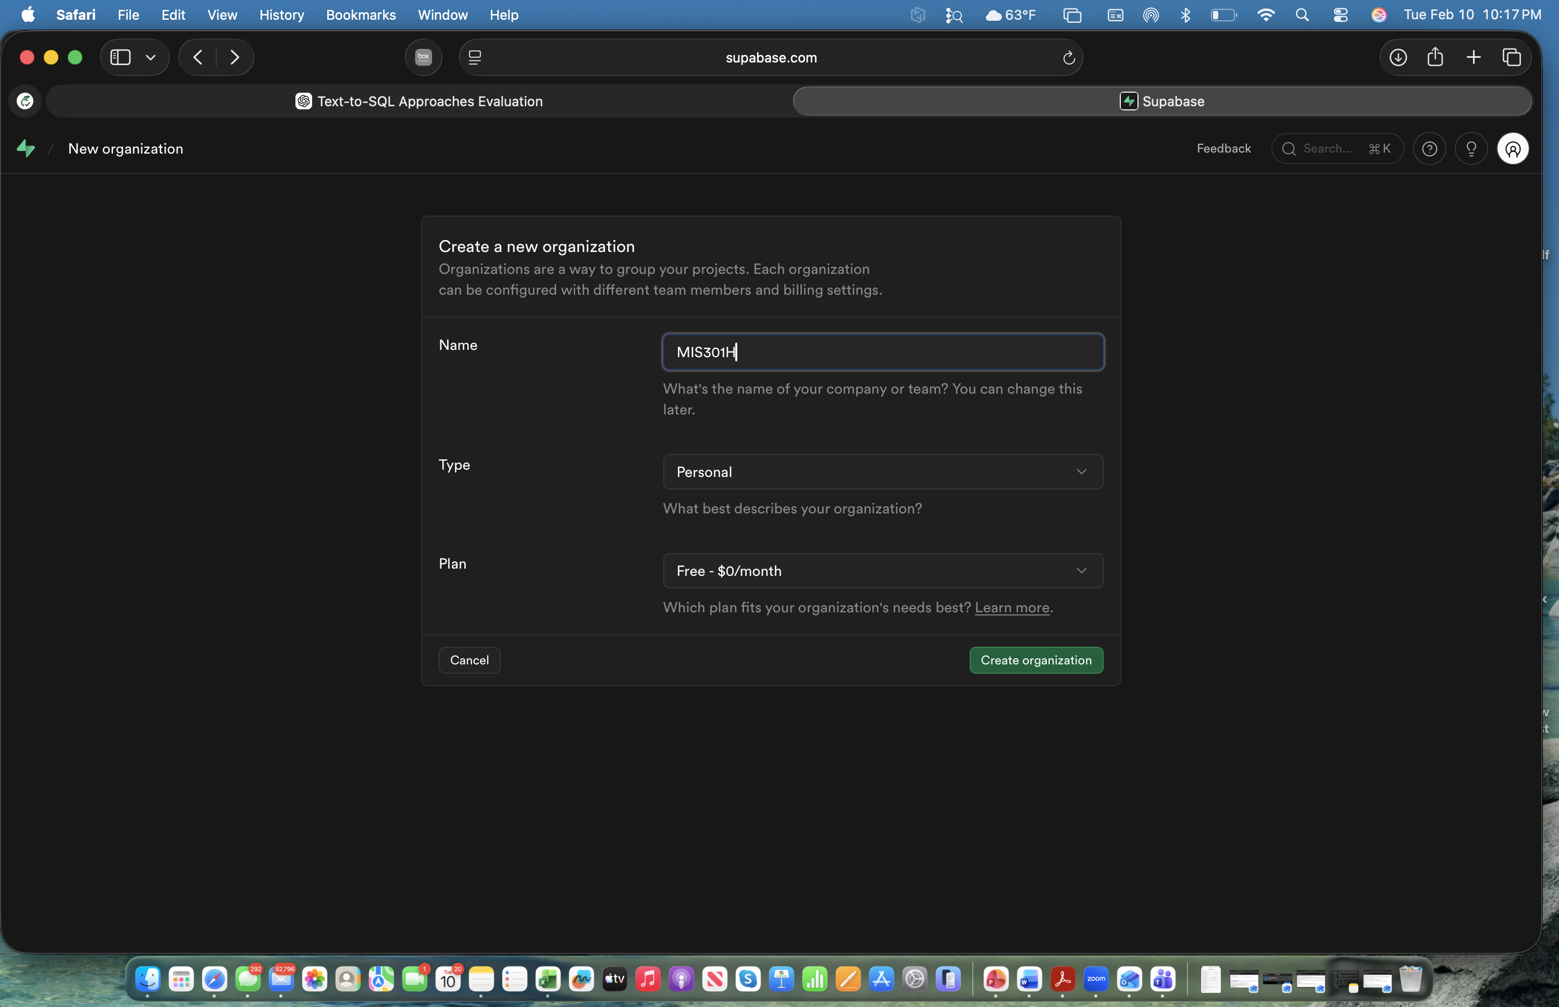

4. Create a new project. Enter project name and a new database password as shown below. Click on “Create new project”

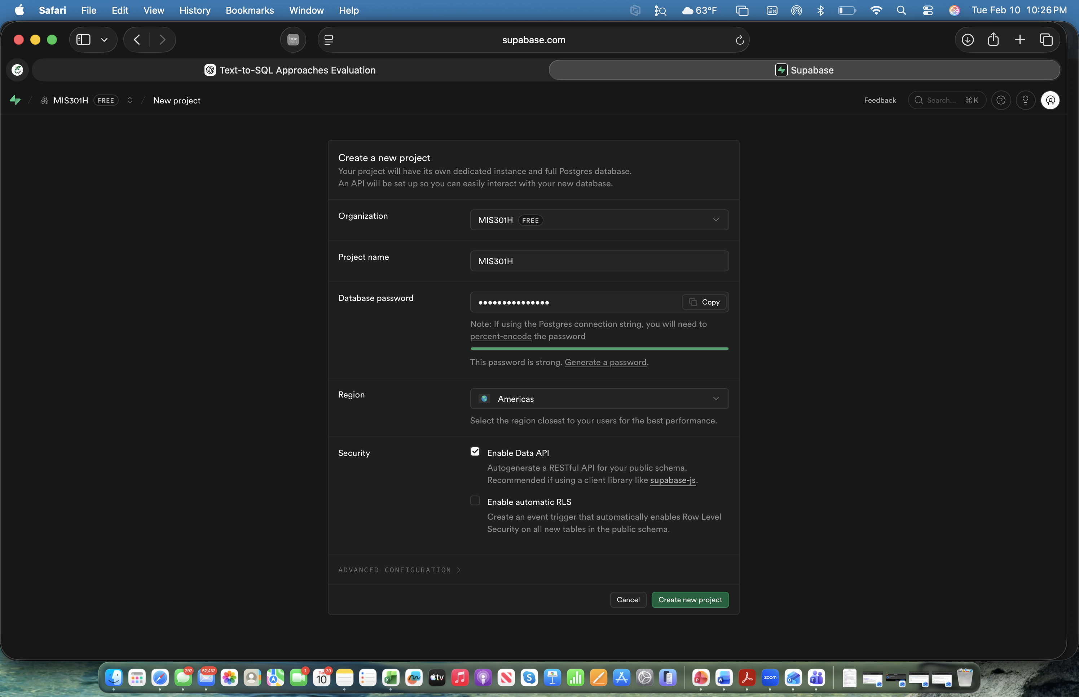

5.Choose SQL editor from the left menu option

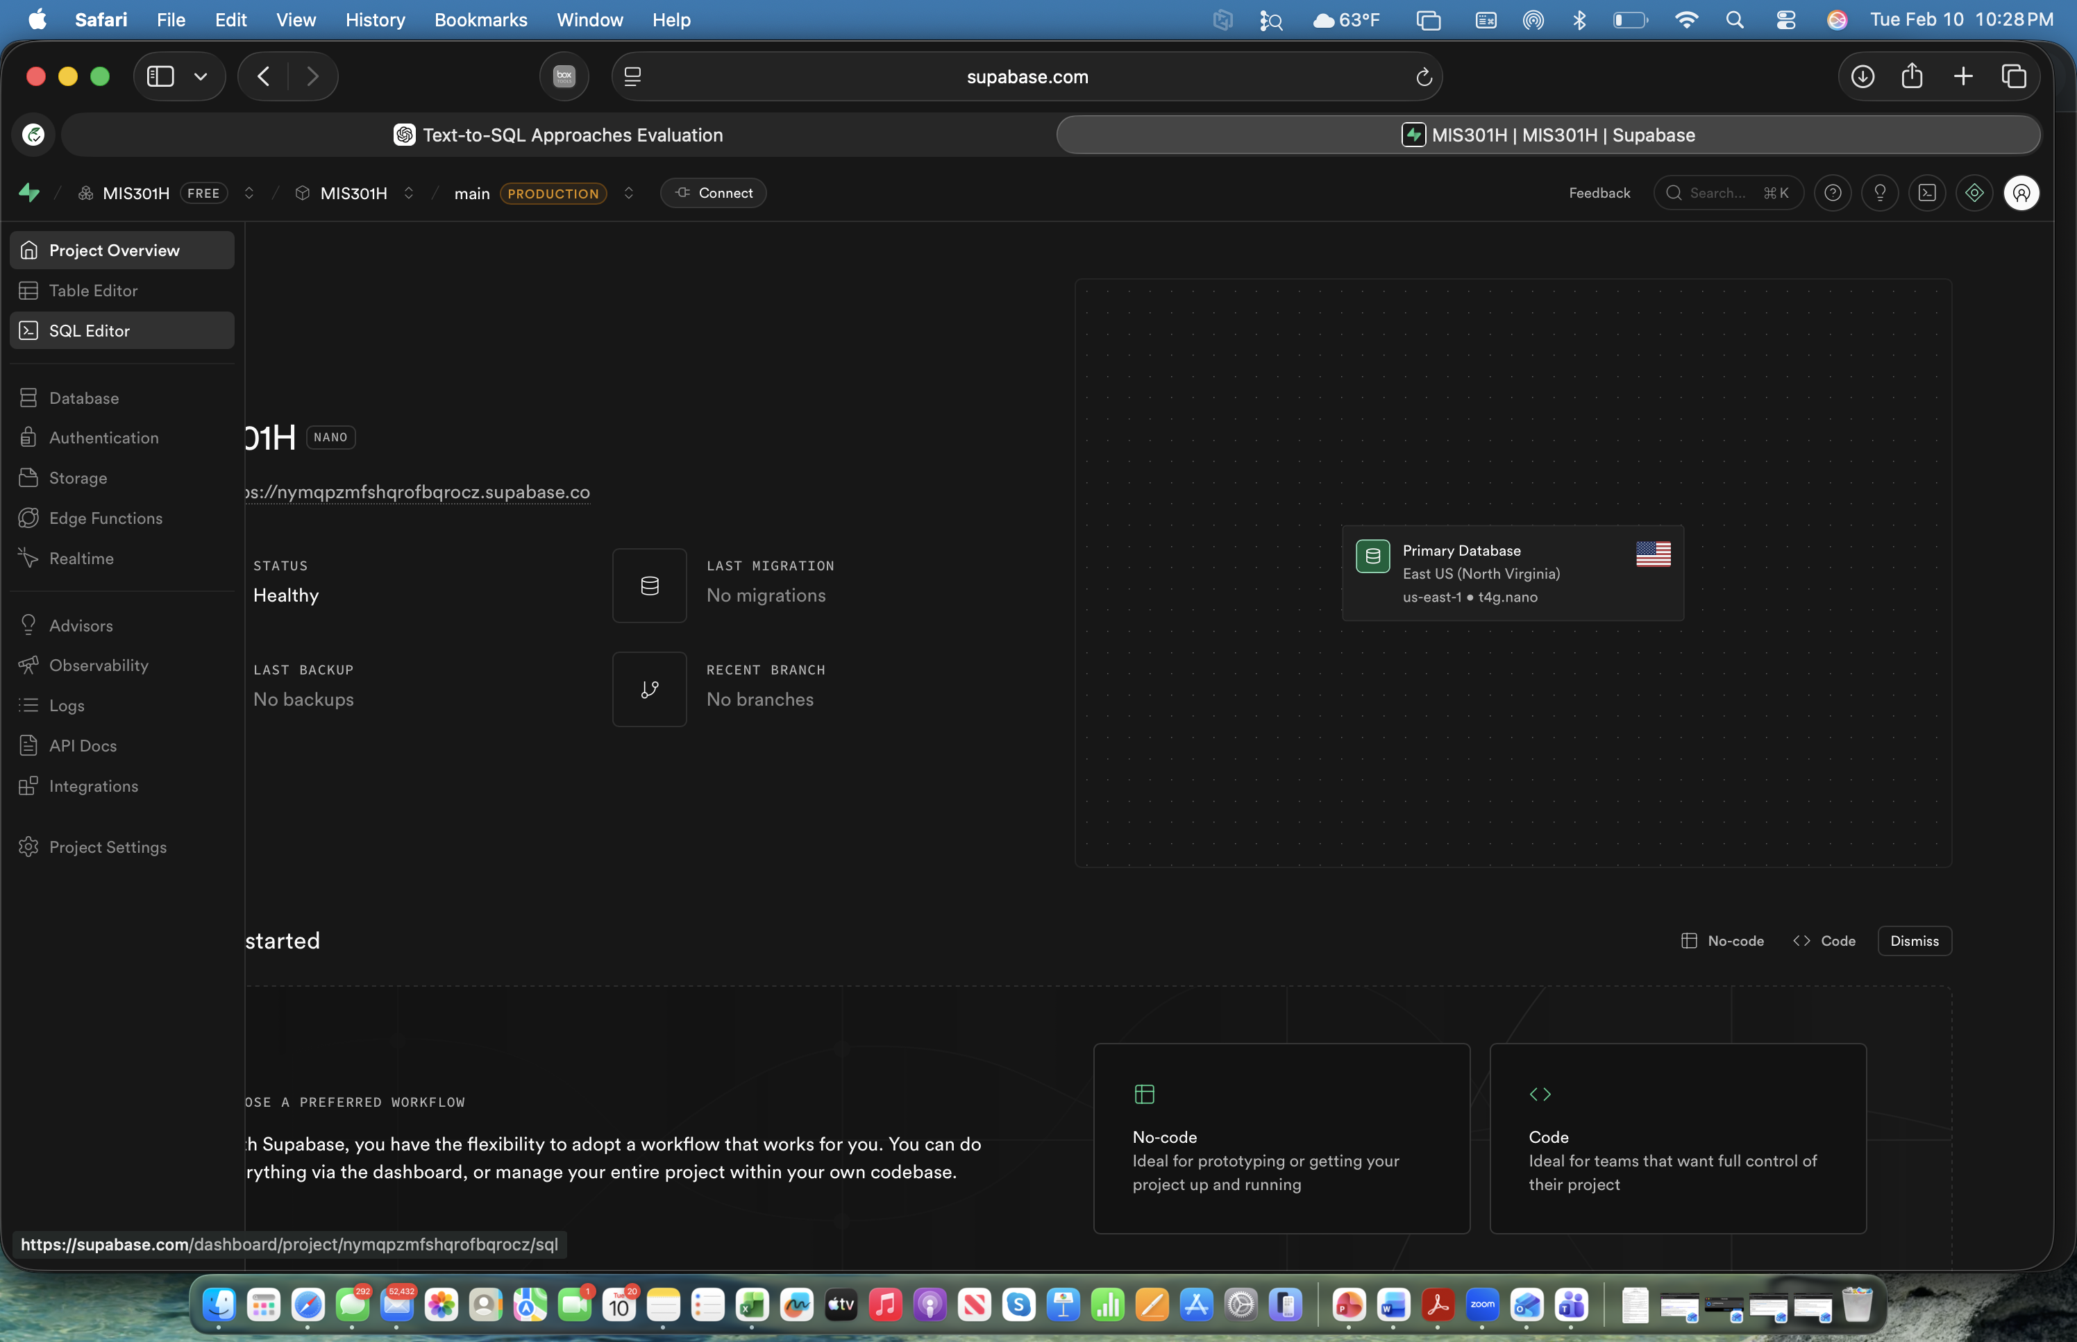
It should open the SQL editor window as shown below
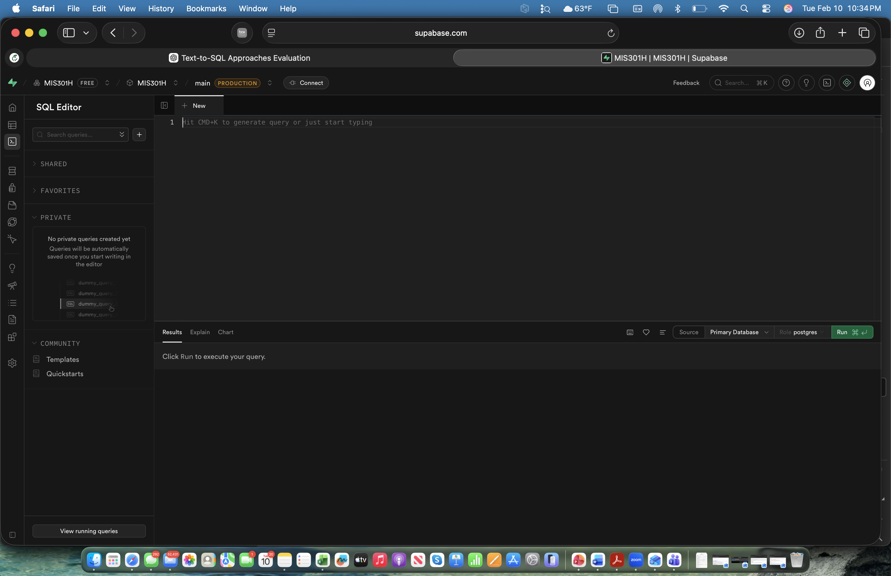
5.Copy all scripts from the Database_Assignment_SQLScript_postgres.txt and paste in the SQL editor box and then click “Run”

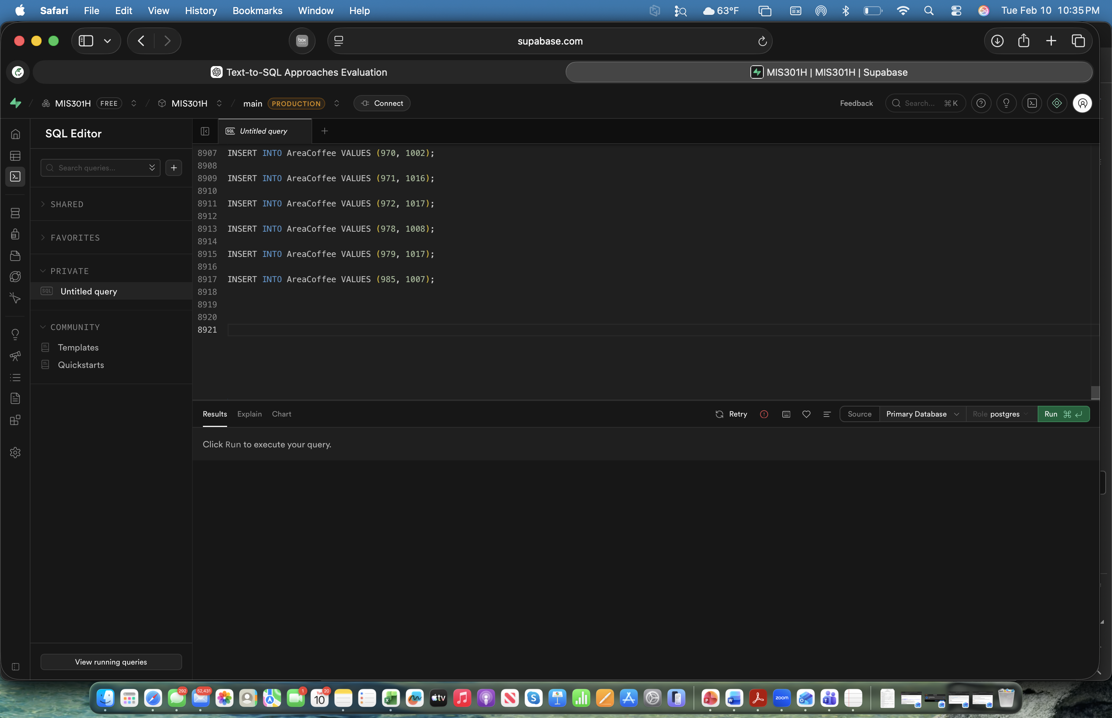
You should see the following message

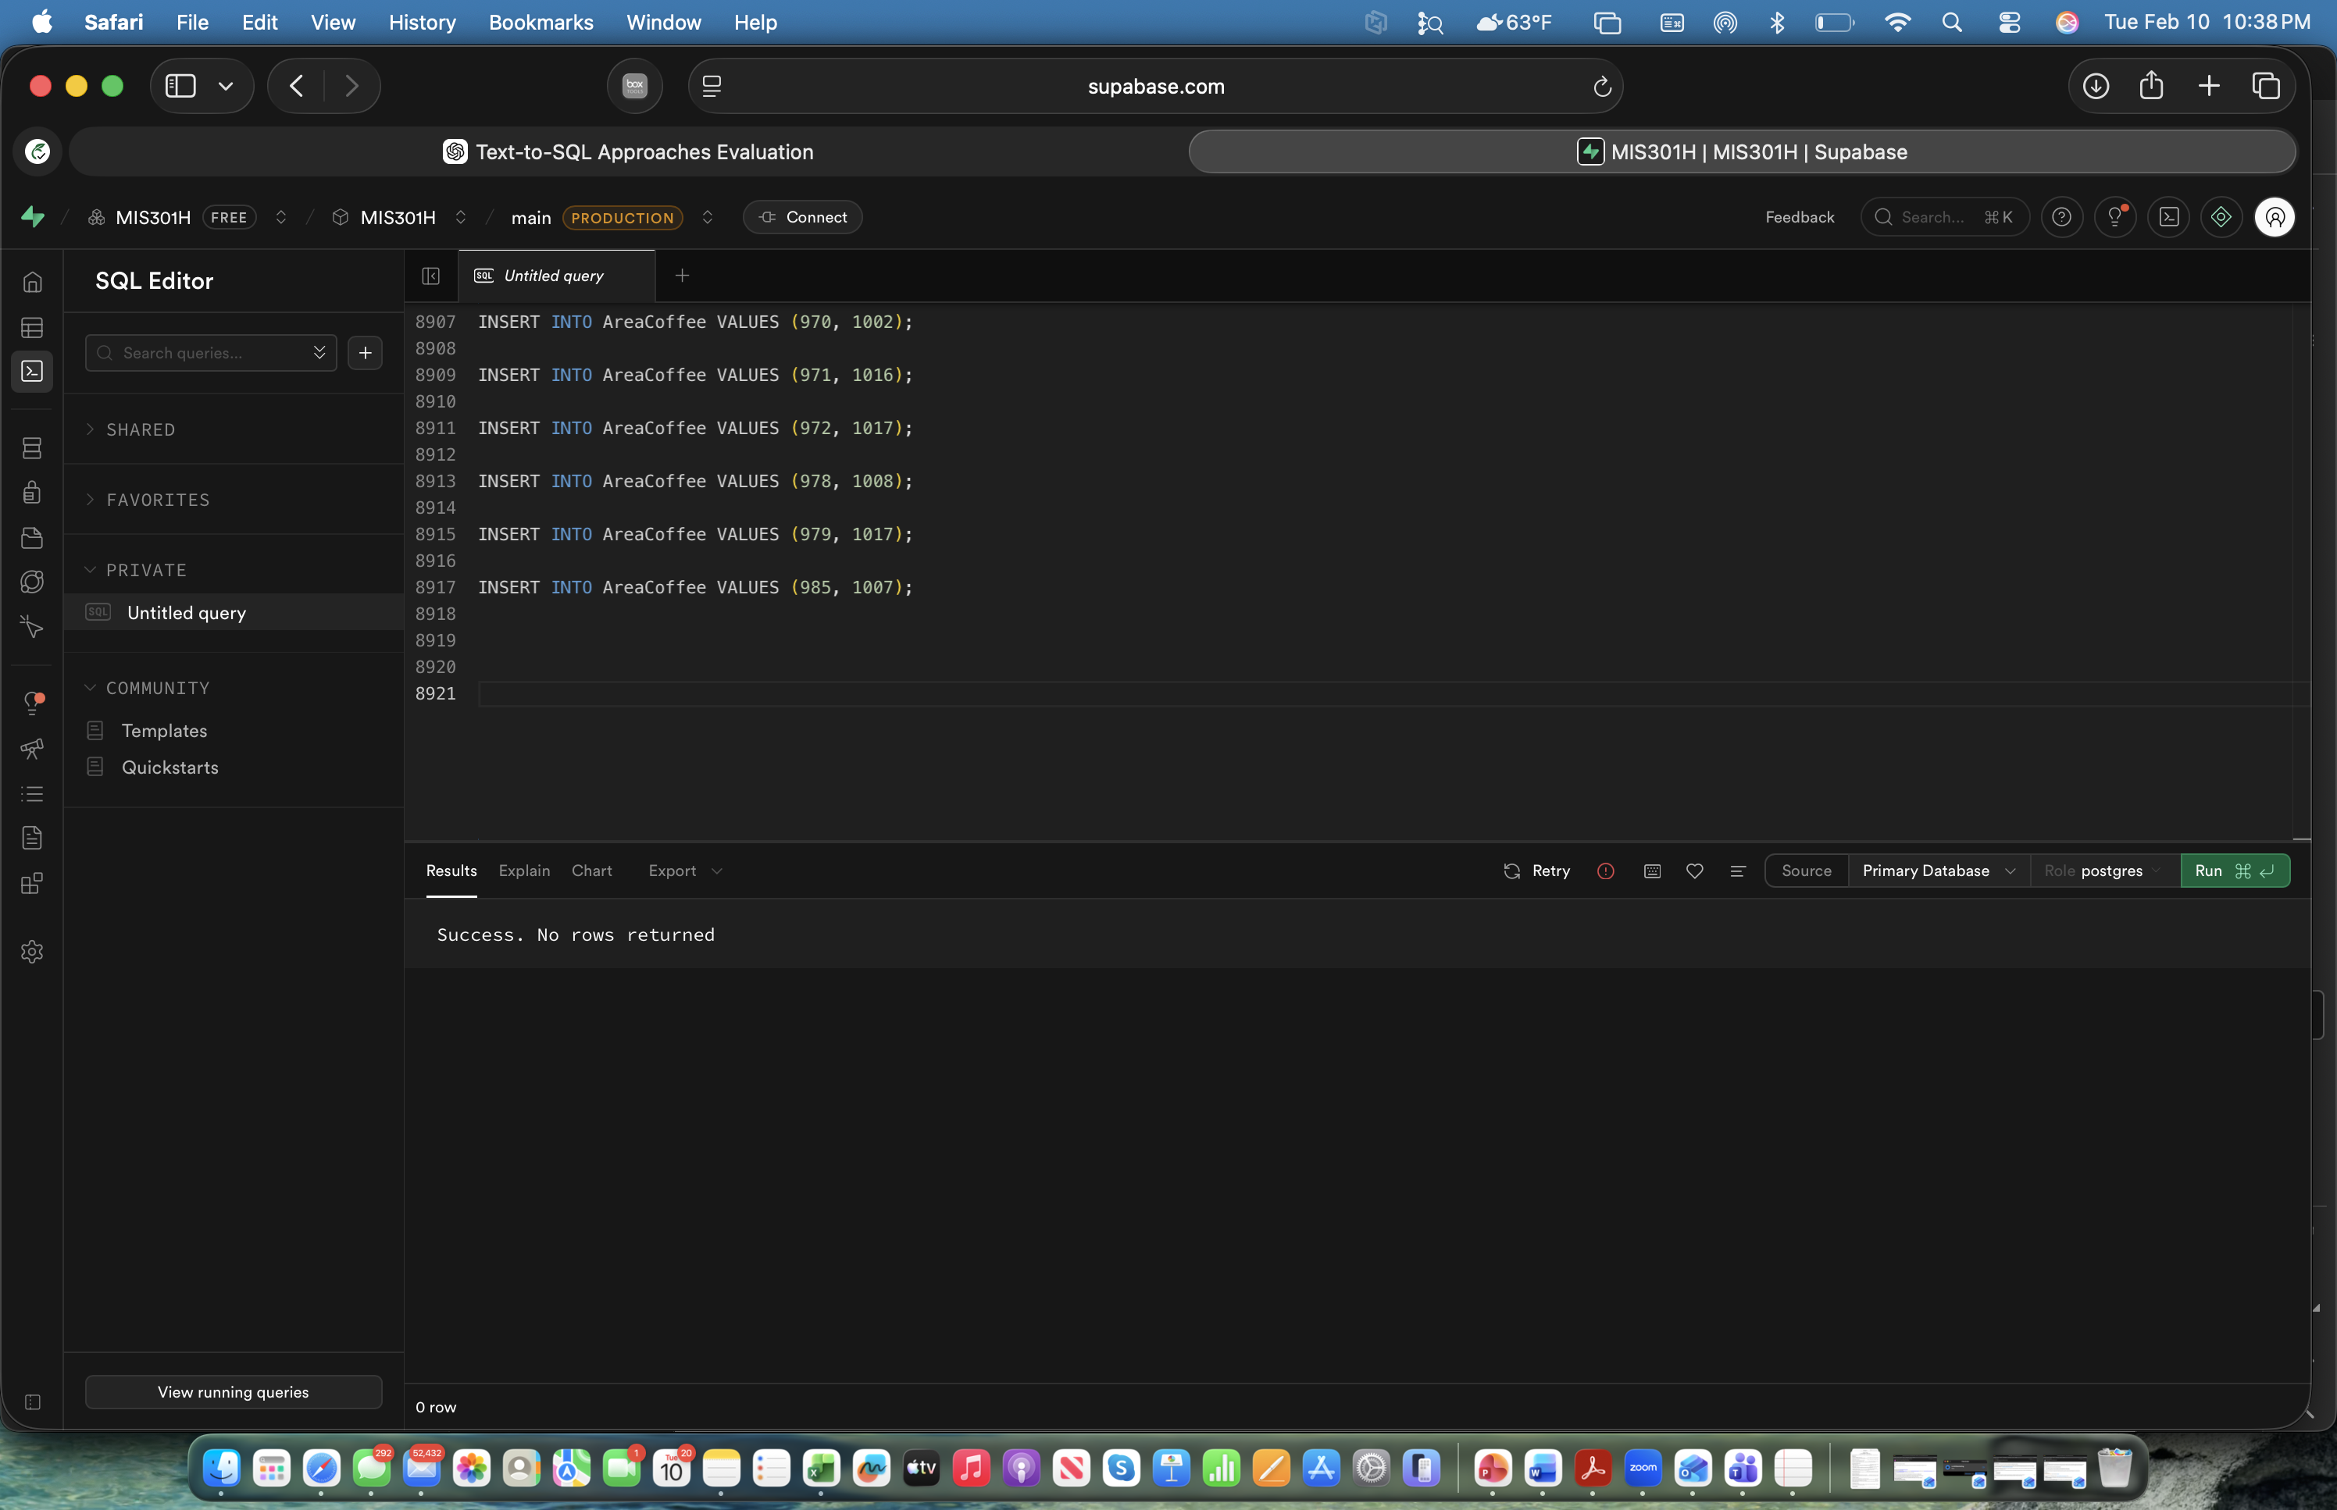

6. Check the tables using the “table editor” option from the left menu
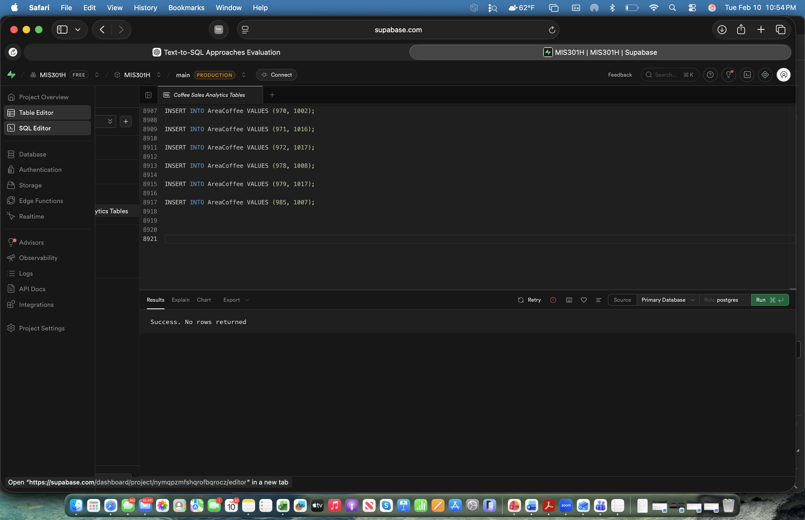
You should see the following tables
